Software Design Description (SDD)

Free WiFi - Hotspot Management System
Version: 1.0
Date: May 2026
Status: Draft
Author: Group 4
NAME | REG NUMBER | STUDENT NUMBER
TENYWA GRACIOUS | 2300717940 | 23/U/17940/EVE
KIIZA DAVID | 1900713286 | 19/U/13286/EVE
SSEWANTE LIVINGSTONE | 2300717770 | 23/U/17770/EVE
DDAMULIRA CHARLES | 2300707974 | 23/U/07974/EVE

Revision History
Version | Date | Author | Description
1.0 | May 2026 | Group 4 | Initial draft

Table of Contents
- Introduction
  - 1.1 Purpose
  - 1.2 Scope
  - 1.3 Definitions and Acronyms
  - 1.4 References
- System Architecture
  - 2.1 Architectural Overview
  - 2.2 Component Diagram
  - 2.3 Deployment Diagram
- Component Design
  - 3.1 Frontend Components
  - 3.2 Backend Components
  - 3.3 Database Layer
- Data Design
  - 4.1 Database Schema
  - 4.2 Data Dictionary
- Interface Design
  - 5.1 User Interface Design
  - 5.2 API Interface Design
- Sequence Diagrams
  - 6.1 Login Flow
  - 6.2 Create Router Flow
  - 6.3 Delete Router Flow
- Appendix
  - 7.1 Technology Stack
  - 7.2 Traceability Matrix

1. Introduction

1.1 Purpose
This Software Design Description (SDD) document describes the architecture and design of the Free WiFi Hotspot Management System. It serves as a blueprint for implementation, detailing system components, data structures, interfaces, and their interactions.

1.2 Scope
This document covers:
- System architecture and component decomposition
- Database schema design
- Frontend and backend component specifications
- API endpoint definitions
- Sequence diagrams for key workflows

1.3 Definitions and Acronyms
Term | Definition
JWT | JSON Web Token for authentication
REST | Representational State Transfer
CRUD | Create, Read, Update, Delete
API | Application Programming Interface
SPA | Single Page Application
ODM | Object Document Mapper

1.4 References
Document | Reference
SRS | ./SRS.md
IEEE 1016 | Software Design Description Standard

2. System Architecture

2.1 Architectural Overview
The system follows a three-tier architecture:
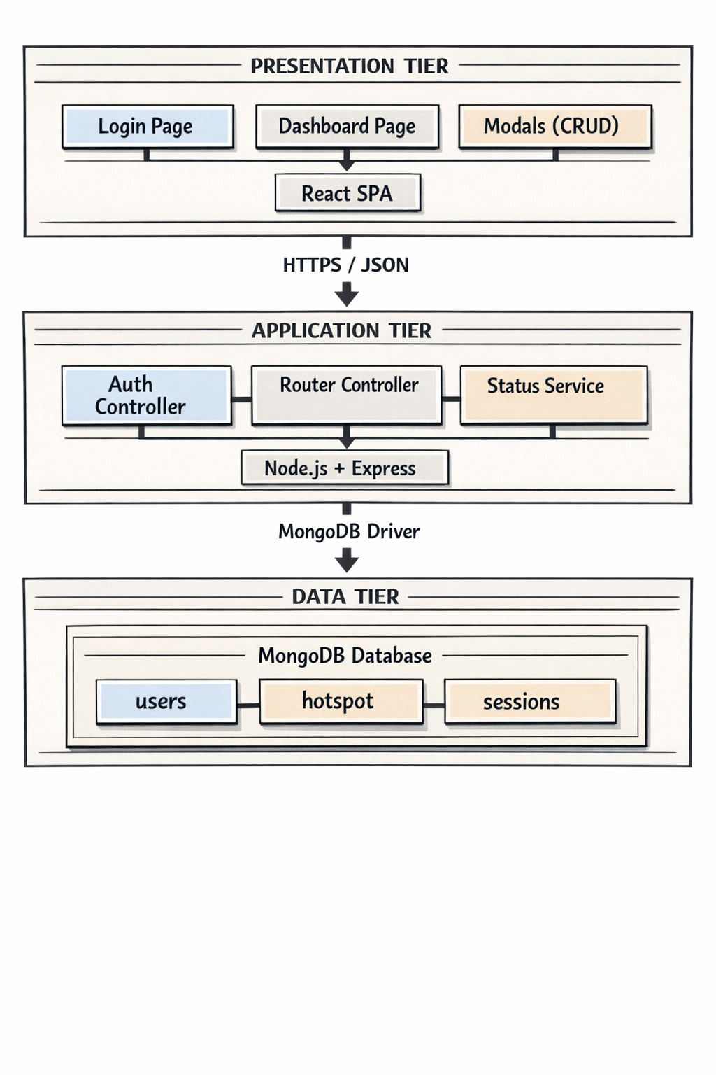

2.2 Component Diagram
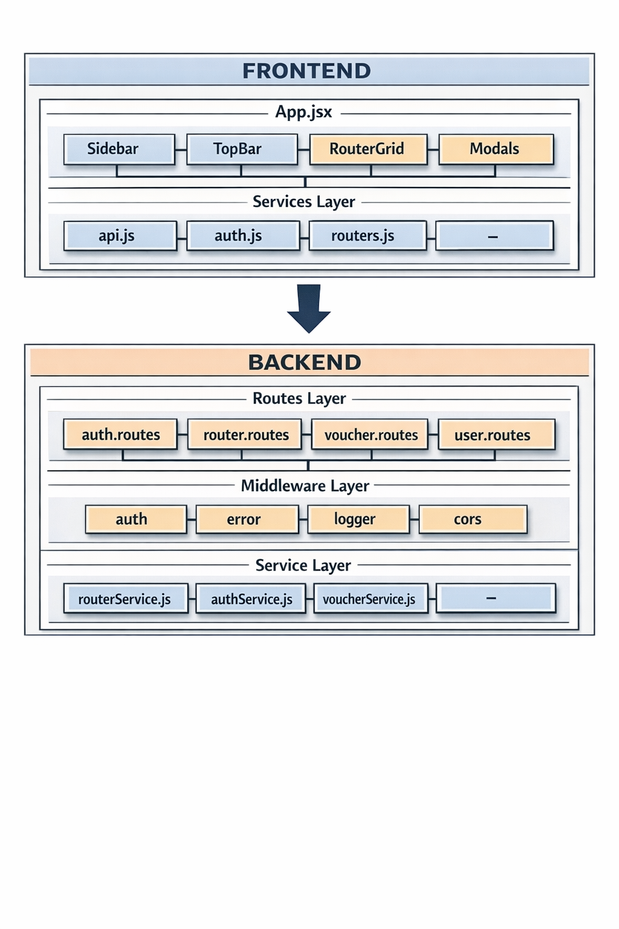

2.3 Deployment Diagram
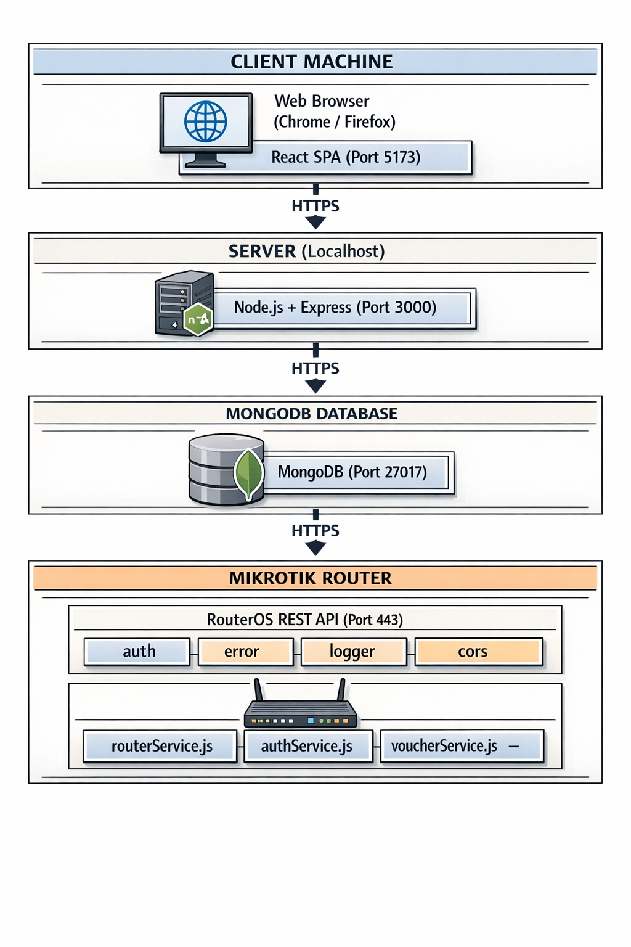

3. Component Design

3.1 Frontend Components

3.1.1 Dashboard Component
File: Dashboard.jsx
Property | Value
Purpose | Main container for router management
State | routers, loading, error, modal states
Methods | fetchRouters, handleAddRouter, handleEditRouter, handleDeleteRouter
Component Tree:

3.1.2 RouterCard Component
File: components/RouterCard.jsx
Prop | Type | Description
router | Object | Router data object
onEdit | Function | Called when Edit clicked
onDelete | Function | Called when Delete clicked
onView | Function | Called when Open clicked
Status Configuration:
```javascript statusConfig = { online: { color: '#00ff9f', label: 'Online' }, offline: { color: '#ff006e', label: 'Offline' }, pending: { color: '#ffbe0b', label: 'Pending' } }

3.1.3 Modals
Modal | File | Purpose
AddRouterModal | AddRouterModal.jsx | Form for new router creation
EditRouterModal | EditRouterModal.jsx | Form for router updates
ViewDetailsModal | ViewDetailsModal.jsx | Read-only router details
DeleteConfirmModal | DeleteConfirmModal.jsx | Deletion confirmation

3.2 Backend Components

3.2.1 Authentication Middleware
File: middleware/auth.js
javascript
authenticateUser(req, res, next)
├── Extract token from Authorization header
├── Verify JWT token
├── Attach user to req.user
└── Call next()

3.2.2 Router Service
File: services/routerService.js
Function | Parameters | Returns
createRouter | userData | { success, router, bootstrapScript }
getAllRouters | userId | { success, routers, count }
getRouterById | routerId, userId | { success, router }
updateRouter | routerId, userId, data | { success, router }
deleteRouter | routerId, userId | { success }

3.2.3 Auth Service
File: services/authService.js
Function | Parameters | Returns
registerUser | email, password, name | { success, token, user }
loginUser | email, password | { success, token, user }
updateProfile | userId, data | { success, user }

3.3 Database Layer

3.3.1 Database Connection
File: databaseConfig.js
javascript
connectToDatabase()
├── Connect to MongoDB using URI
├── Return database instance
└── Handle connection errors

3.3.2 Collections
Collection | Purpose
users | Store user accounts
hotspot | Store routers, vouchers, profiles (single collection pattern)

4. Data Design

4.1 Database Schema

Users Collection
javascript
{
_id: ObjectId,
email: String (unique),
password: String (hashed),
name: String,
routers: [
{ id: ObjectId, name: String, createdAt: Date }
],
settings: {
theme: String,
currency: String
},
createdAt: Date,
updatedAt: Date
}

Hotspot Collection (Single Collection Pattern)
Router Document:
javascript
{
_id: ObjectId,
type: "router",
relatedTo: [ObjectId],
name: String,
hotspotName: String,
ipAddress: String,
api_username: String,
api_password: String (encrypted),
apiToken: String,
userId: ObjectId,
status: "online" | "offline" | "pending",
configStatus: "configured" | "not_configured",
lastSeen: Date,
createdAt: Date,
updatedAt: Date
}
Field | Type | Description | Validation
_id | ObjectId | Unique identifier | Auto-generated
type | String | Document type discriminator | "router"
name | String | Router display name | 3-50 chars
email | String | User email | Valid email format
password | String | Hashed password | bcrypt hash
status | String | Router connectivity | online/offline/pending
hotspotName | String | Hotspot identifier | 3-30 chars, alphanumeric + underscore
ipAddress | String | Router IP address | Valid IPv4 format
api_username | String | Router API username | 2-50 chars
api_password | String | Router API password | 6-100 chars
apiToken | String | Router-server auth token | Auto-generated (hex)
userId | ObjectId | Reference to user | Valid ObjectId
configStatus | String | Router configuration status | configured/not_configured
lastSeen | Date | Last heartbeat timestamp | ISO Date
createdAt | Date | Document creation timestamp | ISO Date
updatedAt | Date | Document last update timestamp | ISO Date

5. Interface Design

5.1 User Interface Design

API Endpoints
Method | Endpoint | Description | Auth
POST | /api/auth/register | User registration | No
POST | /api/auth/login | User login | No
POST | /api/routers | Create router | Yes
GET | /api/routers | Get all routers | Yes
GET | /api/routers/:id | Get router by ID | Yes
PUT | /api/routers/:id | Update router | Yes
DELETE | /api/routers/:id | Delete router | Yes

Request/Response Examples
Login Request:
POST /api/auth/login
{
"email": "admin@example.com",
"password": "password123"
}
Login Response:
{
"success": true,
"token": "eyJhbGciOiJIUzI1NiIs...",
"user": {
"id": "67dbf8a1b4c9a12345678901",
"email": "admin@example.com",
"name": "Admin User"
}
}
Create Router Request:
POST /api/routers
{
"name": "Beach House",
"hotspotName": "beach_wifi",
"ipAddress": "192.168.1.1",
"api_username": "admin",
"api_password": "password123"
}

6. Sequence Diagrams

6.1 Login Flow
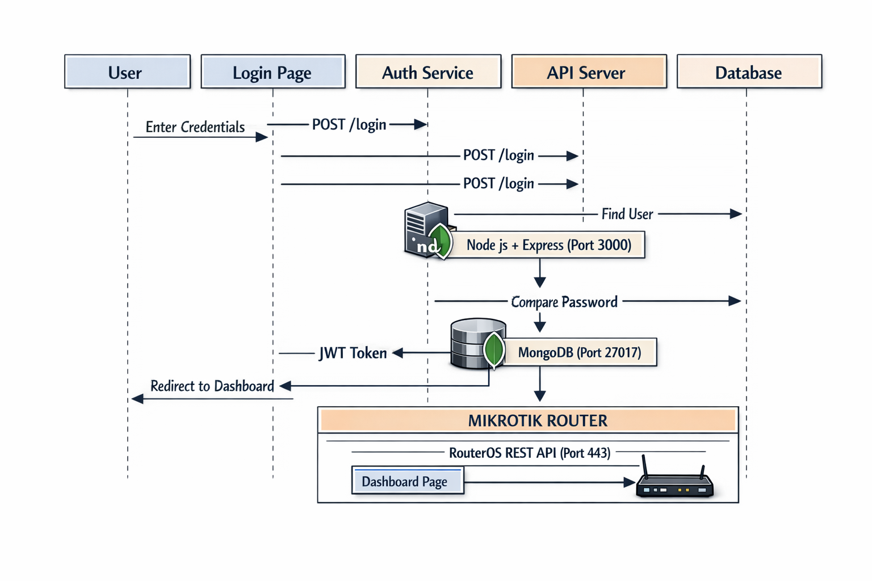6.2 Create Router Flow
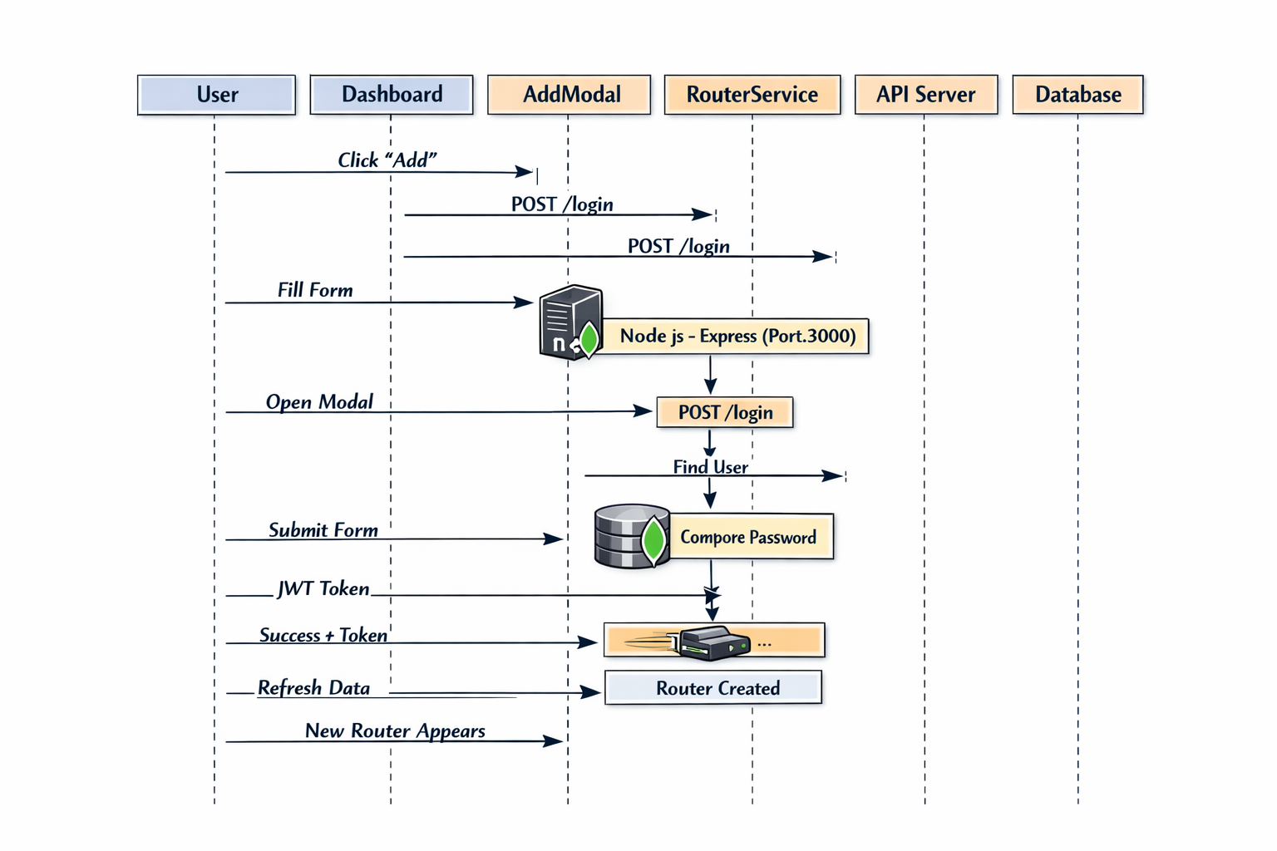6.3 Delete Router Flow
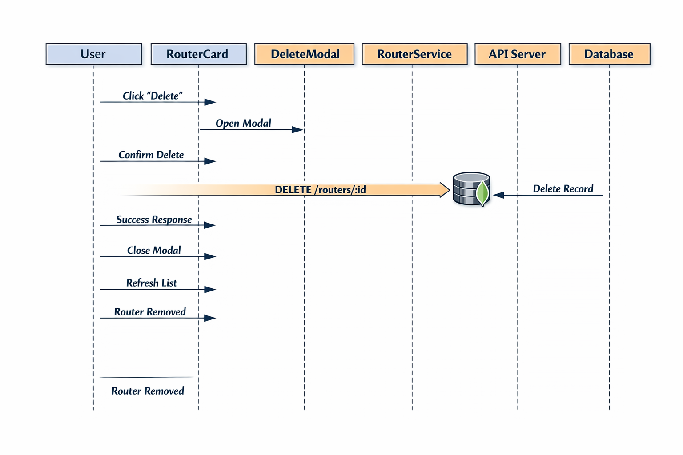7. Appendix

7.1 Technology Stack
Layer | Technology | Version
Frontend Framework | React | 18.x
Frontend Styling | Tailwind CSS | 3.x
State Management | React Hooks | 18.x
HTTP Client | Axios | 1.x
Icons | Lucide React | 0.x
Backend Framework | Express.js | 4.x
Database | MongoDB | 6.x
Authentication | JSON Web Token | 9.x
Password Hashing | bcryptjs | 2.x
API Testing | Postman | -

7.2 Traceability Matrix
SRS Requirement | SDD Component | Status
FR-01 (Authentication) | Auth Service, JWT Middleware | ✅
FR-02.1 (Add Router) | AddRouterModal, RouterService.createRouter | ✅
FR-02.2 (View Routers) | Dashboard, RouterCard, RouterService.getAll | ✅
FR-02.3 (Edit Router) | EditRouterModal, RouterService.update | ✅
FR-02.4 (Delete Router) | DeleteConfirmModal, RouterService.delete | ✅
FR-03 (Status Monitoring) | RouterCard status, lastSeen field | ✅
FR-04 (Bootstrap Script) | generateBootstrapScript helper | ✅
NFR-01 (Security) | JWT, bcrypt, API tokens | ✅
NFR-03 (Usability) | Responsive design, modals, loading states | ✅

Document Approval
Role | Name | Signature | Date
Author | [Your Name]
Reviewer | [Reviewer Name]
Approver | [Project Manager]

